***Champagne Nicolas Feuillatte Palmes d'Or***

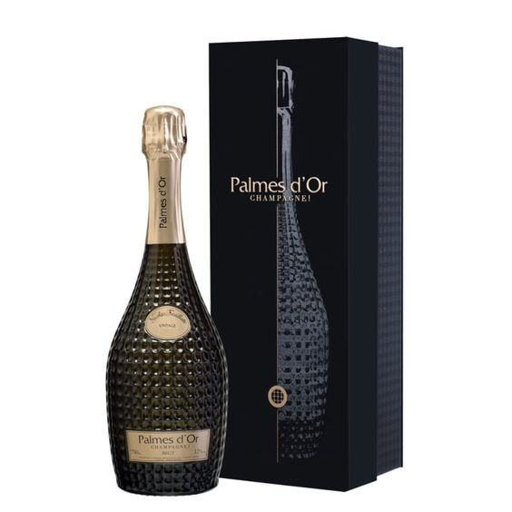

*"If we have to mention high-class French white wines, it is impossible not to mention the name of this wine. The wine was born the brainchild of producer Nicolas Feuillatte. Matured from the combination of The perfect combination of two grape varieties is Chardonnay - Pinot Noir. These are two grape varieties chosen by many winemakers to produce white wine bottles. Possessing a rich and round taste, the grape variety has decided. Determine the dominant flavor of the bottle.  
  
Besides, when enjoying, you also feel the rich variety of aromas from other fruits such as pears or apples.  
  
The 12% concentration is enough to show the lightness and romance in the style of the bottle. With a well-balanced structure, a moderate amount of smooth tannins, the wine has always been the target of many users and has become one of the top premium white wines loved and sought by many. . Suitable wine for you to choose to use as a gift for your boss and important partners."*